GloboDiet RI Technical Overview
last update: 2015-04-16
This document serves as first starting point for new employees joining the DEX group for technical work (e.g. technical coordinators, developers). It provides an overview to the research infrastructure on GloboDiet-related servers, applications and technologies. It shall provide a quick overview and reference also to more detailed documents to shorten the training period.
Warning: The referenced documents partially contain passwords for the server infrastructure.

GloboDiet RI software components

The DEX group has among others the objective to provide tools that enable the conduction of “24 hour dietary recall” (24HDR) studies and the maintenance of the result data. To this end, the DEX group maintains the GloboDiet research infrastructure (GloboDiet RI or GD-RI). They consist of desktop and server-based applications as illustrated in Figure 2.
GloboDiet Research Infrastructure (GloboDiet RI)
GloboDiet server (e-SMP)
Interview Manager appl. (IMapp)
Maintenance & Settings appl. (MSapp)
SCapp
GloboDiet desktop applications
GloboDiet application (GDapp)
Data Entry
Recipe Manager

Figure 1: The desktop/server applications of the GloboDiet research infrastructure

The desktop and server tools are designed for a seamless integration as described in the following and the relations being illustrated in Figure 2.

GloboDiet applications: A set of desktop applications – GloboDiet application (GDapp), DataEntry, RecipeManager – for 24HDR data collectoin through interview based studies (or with DataEntry) and data maintenance/cleaning of comments.

GloboDiet server: A web infrastructure that enables data centralization, visualization providing also maintenance functionalities (filtering, notes, DB preparetations atc.). The server is realized by the e-Standardized Methodological Platfrom (e-SMP) and contains the three modules MSapp, IMapp and SC app as outlined hereafter.
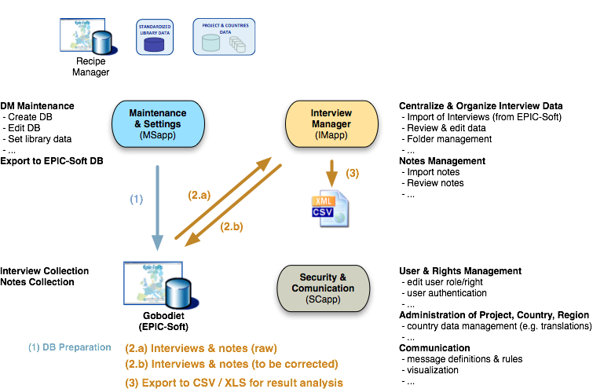
Figure 2: Relations & functionalities of GloboDiet application and GloboDiet server (e-SMP)

GloboDiet desktop application(s)
Characterization: The GloboDiet application, or GDapp, as well as DataEntry, RecipeManager are Windows desktop application that enable “24 hour dietary recall” (24HDR) studies by providing a mean to record the consumed food in a structured way and using the GloboDiet methodology (formerly EPIC). For more information on GloboDiet refer to the training materials.

Requirements  - Microsoft Windows  - Microsoft SQL Server 2008 R2 (v10.50+)  - Microsoft .NET Framework 4.0 | Technologies  - C# (backend)  - Visual Basic (frontend)  - Google library for Excel (.xls) access (ExcelLibrary.dll)  Data Exchange  - Manual file exchange  (im-/export of XML/CSV files in user interf.)

A good impression of the GloboDiet software can be obtained by the training video as well as other training materials and also by the user manual (see in this folder).

Please note that GloboDiet (formerly known as EPIC-Soft) evolved over years (partially even decades) and integrates several technologies. The initial version was developed for MSDOS and has been migrated to Windows. This is still represented in the GloboDiet DB preparation/update workflow using the migration tool (to be replaced by MSapp of e-SMP).

GloboDiet server (e-SMP)
The e-SMP realizes the GloboDiet server part by provide an infrastructure
- to storage GloboDiet (GD) interview results data centrally on a web based infrastructure
- to provide a mean for GD result data management (list visually, filter, sort, search, export/import, support data cleaning etc.)
- to provide a mean to support the DB preparation and update
- future plan: to provide a further building block for an integrated virtual research environment (VRE)

e-SMP is realized as a web based application, i.e. functionality is provided by an application server with web-based (Silverlight) frontend. The access takes place by standard browsers with a Silverlight plugin. The server contains the following major application modules
- Interview Manager application (IMapp): centralization and management of interview result data collected with GloboDiet
- Maintenance & Settings application (MSapp): Preparation and maintenance of the database, users, access policies etc.

Requirements  Server  - Microsoft Windows Server 2008  - Microsoft SQL Server 2008 R2 (v10.50+)  - Microsoft IIS  - Microsoft .NET Framework 4.0  - Silverlight 5 Runtime Environment  Client  - Web browser with Silverlight plugin | Technologies  - C# (backend)  - Silverlight (frontend)  Data Exchange  - Manual file exchange  (im-/export of XML/CSV files in web-based user interface)

Server Infrastructure
The GloboDiet desktop applications (& DataEntry, RecipeManager) are desktop applications. Hence, the GloboDiet server infrastructure is related to e-SMP needs, software tests and development support (e.g. source code repository subversion).

Server Hardware & Infrastructure
The main IARC infrastructure contains vmWare virtual servers that are hosted on a blade hardware infrastructure as illustrated in Figure Figure 3 with the following characteristics.
- Server situation at ITS/IARC situation (December 2014):
  - 6 Blade-server with load-balancing (maximum – more servers need another licence)
  - Machines: HP ProLiant BL460c with 250GB RAM each (1.5 TB RAM altogether)
  - 89 active virtual machines (Vmware)
  - As impression, see specification of an example of many possible several configurations:
http://h20195.www2.hp.com/v2/default.aspx?cc=us&lc=en&oid=5204417
- Network characteristics:
  - Three zones: Internet / demilitarized zone (DMZ) / LAN
  - Servers connections within each zone: Gigabit Ethernet
  - DMZ LAN connection: 2x 100 Mbit Ethernet
  - Server Workstations (e.g. fileservers) within LAN: 100 Mbit (due to switches)

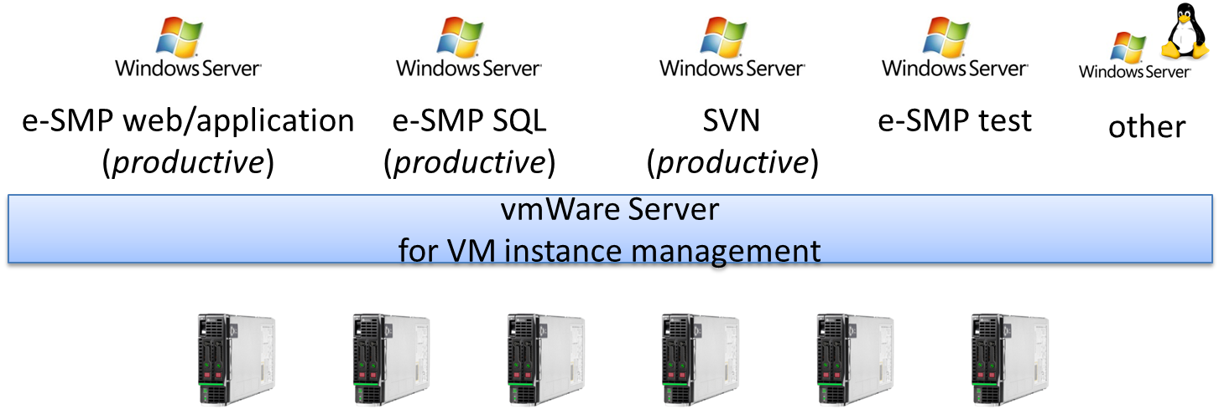
Figure 3: Infrastructure realization

Server System Characteristics
The e-SMP currently server infrastructure and installed major software is listed below, which are realized as virtual machines. Hence, the indicated hardware is emulated and the CPU not representative. The information are taken from the document servers_informations.docx, which also provides the system login/passwords (see also other files in the folder of this document).

Web
- Hostname: emp-dex-web.iarc.fr
- IP : 193.51.164.136
- Characterization: 1 Intel Xeon CPU (2.53 GHz), 6GB RAM, 60GB (C:) and 40GB (D:) disk space
- Major software: Microsoft IIS 7.6.5.7600.16385

SQL
- Hostname: emp-dex-sql.iarc.fr
- IP : 193.51.164.137
- Characterization: 1 Intel Xeon CPU (2.53 GHz), 4GB RAM, 60GB (C:) and 40GB (D:) disk space
- Major software: Microsoft SQL Server Management Studio 10.50.2500.0
Microsoft Analysis Services Client Tools 10.50.2500.0
Microsoft Data Access Components (MDAC) 6.1.7601.17514
Microsoft MSXML 3.0 6.0
Microsoft Internet Explorer 9.0.8112.16421
Microsoft .NET Framework 2.0.50727.5466

Test
- Hostname: emp-dex-test.iarc.fr
- IP : 193.51.164.133
- Characterization: 1 Intel Xeon CPU (2.53 GHz), 4GB RAM, 2x 40GB disk space (C: and D:)
- Major software: Microsoft SQL Server Management Studio 10.50.2500.0
Microsoft Analysis Services Client Tools 10.50.2500.0
Microsoft Data Access Components (MDAC) 6.1.7601.17514
Microsoft MSXML 3.0 6.0
Microsoft Internet Explorer 9.0.8112.16421
Microsoft .NET Framework 2.0.50727.5466

SVN
- Hostname: emp-dex-test.iarc.fr
- IP : 193.51.164.134
- Characterization: 1 Intel Xeon CPU (2.53 GHz), 4GB RAM, 2x 40GB disk space (C: and D:)
- Major software: VisualSVN Server Manager 2.5.2
- Note: see file TODO with additional information about the checkout of source code.

GloboDiet Evaluation
- Hostname: gdevaluation.iarc.lan (direct access only from inside iarc network)
- IP : 10.10.13.45
- Major software: GloboDiet application with UK demo database (no interviews)

Backups
Backups of the server systems (i.e. virtual machines) are done by the ITS, containing also the recovery. E-SMP DBs can be backed up daily by a script & windows tasks; it has been suspended since there is currently no active work (no DB changes). More information about the DB Backup are available in the file “BACKUP_eSMP.docx”.

System & Data Backup
Subject | Interval | Contact | Backup Location
e-SMP server system VMs | Daily/weekly?? | ITS | “ITS intern”
e-SMP databases | Suspended | Gabriel Grange | ftp server
Source codes | backup through e-SMP system VMs

